Cherry Hill School & New Bridge Center October 2017
Lisa DiCostanzo, Admin. Asst. X300 Denise Heitman, Principal X302 Sabrina Johnston, Nurse X304
Judy Albrizio, Admin. Asst. X301 Beth Rosen, Asst. Principal X326 To report an absence, press 1
Leslie Blute, Admin. Asst. X323 201-261-3405

Sun | Monday | Tuesday | Wednesday | Thursday | Friday | Sat
1 | 2  WEEK OF RESPECT  (Oct.2-6)  WRAP Day-Wear something that represents your culture or heritage  Pizza Lunch | 3  Unique Day-Wear something that represents you  Blimpie Lunch | 4  Go Green Day-Wear Green  PDIA 3:15-4:15  Bagel Lunch | 5  Throwback Thursday-Wear clothes that were in style in a previous decade  Blimpie Lunch | 6  School Pride Day-Wear school colors or Spirit Wear (Red & White)  Ice Cream Sale-3pm  Pasta Lunch | 7
8 | 9 No School  Staff Professional Development  BOE Agenda posted @ riveredgeschools.org  Columbus Day | 10  ELL Parent Night-7pm NBC PR  Blimpie Lunch | 11  BOE Mtg. 7:30pm @ CH  PDIA 3:15-4:15  Bagel Lunch | 12  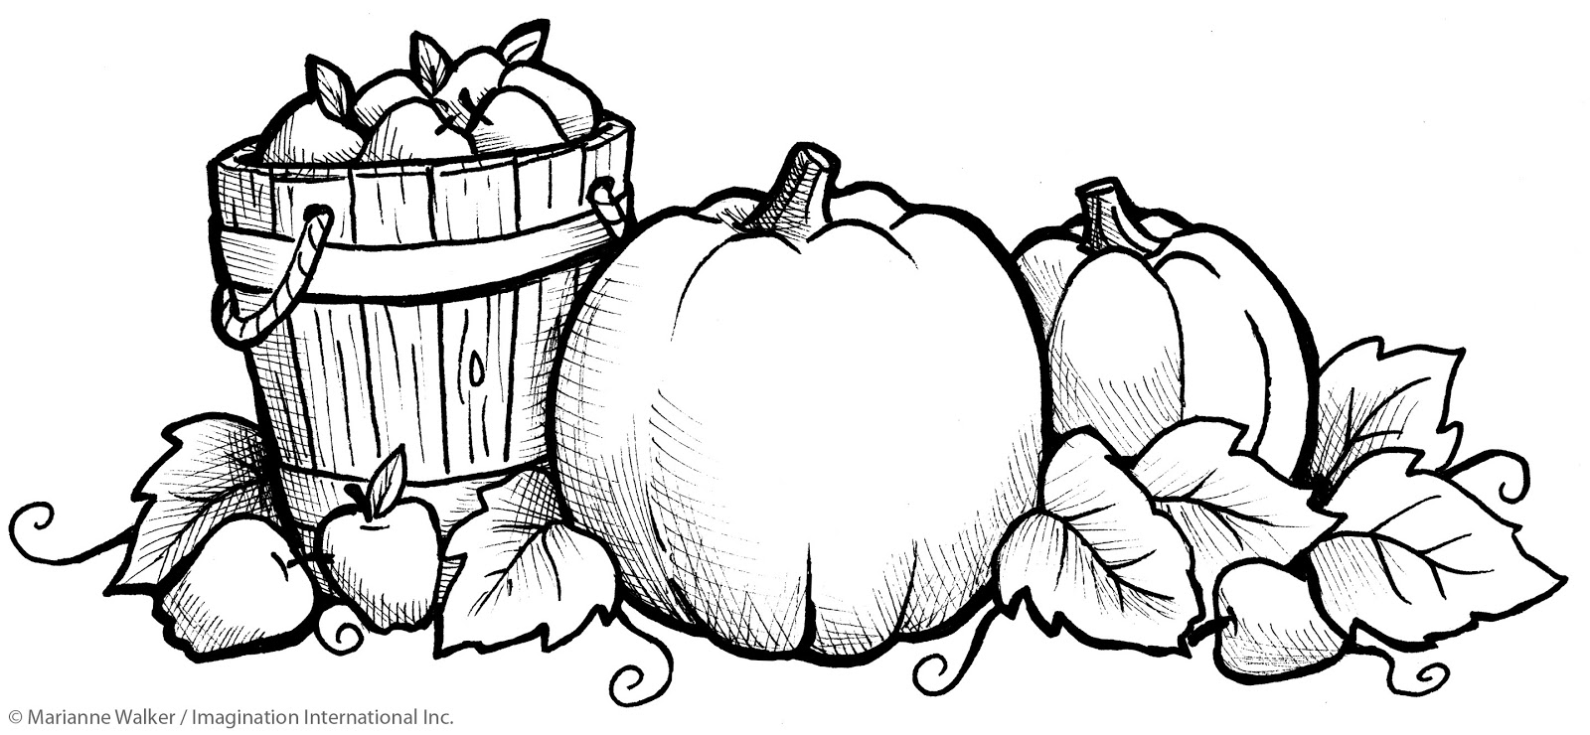  Blimpie Lunch | 13  6th Gr. Bake Sale 3pm  Pasta Lunch | 14
15 | 16  BOE Agenda posted @ riveredgeschools.org  PTO Mtg. 7pm  Pizza Lunch | 17  Blimpie Lunch | 18  BOE Mtg. 7:30pm @ RS  PDIA 3:15-4:15  Fifth Gr. Field Trip  (5C&part of 5L)  Bagel Lunch | 19  Fifth Gr. Field Trip  (5H&part of 5L)  Blimpie Lunch | 20  Fifth Gr. Field Trip  (5K&part of 5L)  Pasta Lunch | 21
22 | 23  2nd Cup of Coffee-8:45am  @ RS Old Gym  Pizza Lunch | 24  Blimpie Lunch | 25  PDIA 3:15-4:15  Bagel Lunch | 26  Blimpie Lunch | 27  PTO Boo Bash  6-8pm CH Gym  Pasta Lunch | 28
29 | 30  Pizza Lunch | 31  Halloween  Mini Boo Bash (PreK-Gr.1-during school hours)  Halloween Parade 2pm  Blimpie Lunch

