A Parent’s Guide to Digital Citizenship
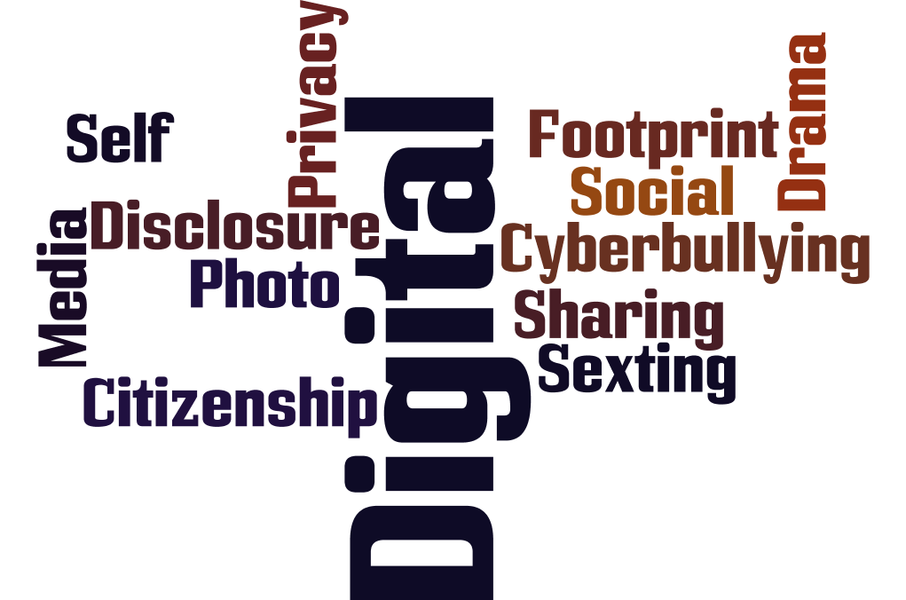

Join our Guest Speaker to learn more about one of the most important topics in your children’s lives – Digital Citizenship – their day-to-day interaction with technology.
Media and technology are at the very center of all our lives today -- especially our children’s. Kids today spend over 50 hours of screen time every week. The media content they consume and create has a profound impact on their social, emotional, cognitive, and physical development. Learning how to use media and technology wisely is an essential skill for life and learning in the 21st century.
Join us as we explore what should matter most to parents.
Topics include:
- What is Digital Citizenship and why does it matter?
- The indelible impact of a negative Digital Footprint and the college admission process
- Social media - leaving a positive digital footprint
- Protecting your children in your personal social feeds
- The Family Media Agreement - your child’s first, best contract
WHEN: October 18th, 2017
WHERE: River Dell Regional High School – Media Center
TIME: 7:00pm

Common Sense Education is a nationally recognized, nonpartisan, nonprofit organization. It is a trustworthy, leading resource that provides high-quality digital literacy and citizenship programs to educators and school communities. Over 105,000 schools have downloaded the Common Sense Digital Citizenship curriculum.
Eduscape is a leading professional development organization based in Montvale, New Jersey. The company has worked with over 600,000 teachers and 400 districts across the United States. They are Common Sense Education’s partner in delivering Digital Citizenship training to students, teachers and parents in North America.
