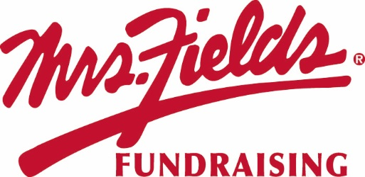

Please support our
CHERRY HILL SCHOOL PTO
Your Sale Starts Today!! | Pick Up Information:
Sale Starts: October 23, 2017  Order Form and Money Due:  November 6, 2017 | After all the orders have been placed all families will receive pickup information

HOW TO HELP?
* Show the catalog to friends, relatives and co-workers.
* Please, no unsupervised door-to-door selling.
* Please collect payment when you take the order. (No Tax)

HOW IT WORKS…
1. Make checks payable to CHERRY HILL P.T.O.
2. Use the order form to keep track of the orders you are collecting.
2. Please fill out your envelope completely with your name, teacher, class and phone number.
3. Please turn in the envelope & one copy of the order form, filled out completely with money enclosed. Keep the other copies of the order form for your records.

If you have questions please contact: FRAN MUNOFO at fmunofo@optimum.net or 201-705-3432

INCENTIVE/PRIZE PROGRAM: For each 10 Items sold, that participant will receive a Free box of
Mrs. Fields Chocolate Chip Cookie Dough!!

